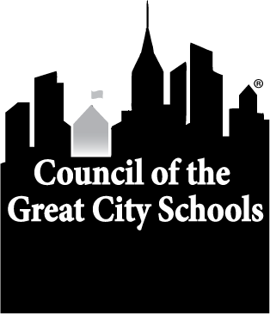

Council of the Great City Schools

Travel Expense Reimbursement Request

Males of Color Policy Conference

Please return form and original receipts to:

Terry Tabor, Conference Manager

Council of the Great City Schools
1331 Pennsylvania Avenue, N.W., Suite 1100 N
Washington, D.C. 20004

Information on visit:
School district being visited
Dates of visit
CGCS Staff Person Leading the Group

Information on Team Member:
Name
School District
Make check payable to
FULL Mailing address
Phone number
email
Social Security Number/Tax ID #

Information of reimbursable costs:
Airfare, Bus, Train, Rental Car, Gas (attach passenger original receipts)
Date travel to visit: | Date travel home:
Airport parking
Ground transportation (private vehicle) _____ miles x $0.535/mile (2017)
Shuttle/Taxi (itemize and report total here)
Meals (not included as part of meeting – attach receipts)
Other (Must identify)
TOTAL EXPENSES CLAIMED for reimbursement

Please note: This completed form with all original receipts must be sent to the address above within two (2) weeks of the return travel date. Original receipts are required for all expenses noted above. No reimbursements will be paid after 3 weeks of return date. Hotel room and tax are directly billed to CGCS. Alcoholic drinks, in-room movies and other personal expenses are not reimbursable.

Certification:
I hereby certify that the above is a true statement of travel expenses.
Signed: | Date:

If you have any questions, please contact Terry Tabor or Teri Trinidad at (202) 393-2427

